Tableau Visualisations of the data

Sheet one based on Fire radiation in a Day.

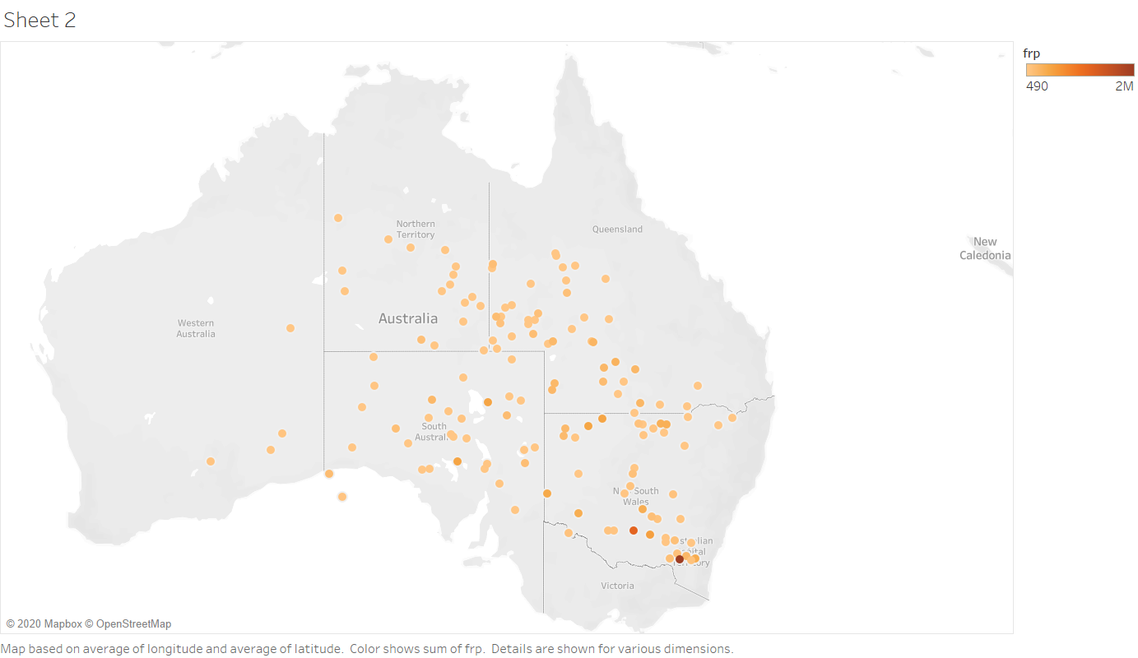

Map with day and night observations:

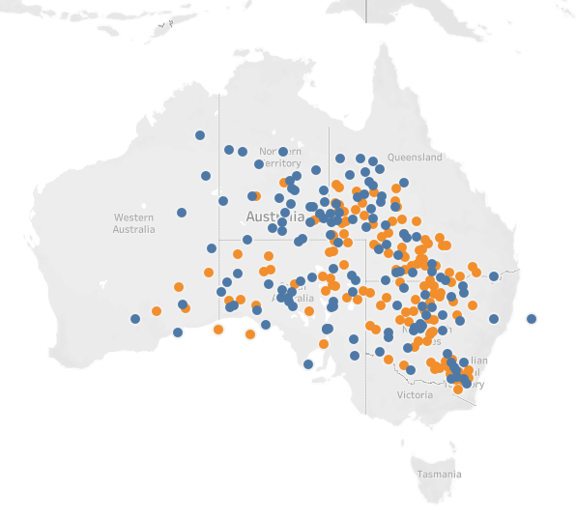

Map with confidence levels of day wise notified data

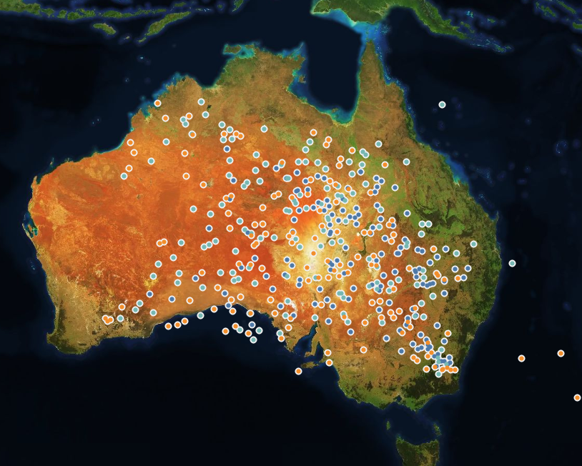

These above pictures carried out in visualising the data available to us from Aus_bushfire.csv present in the files.